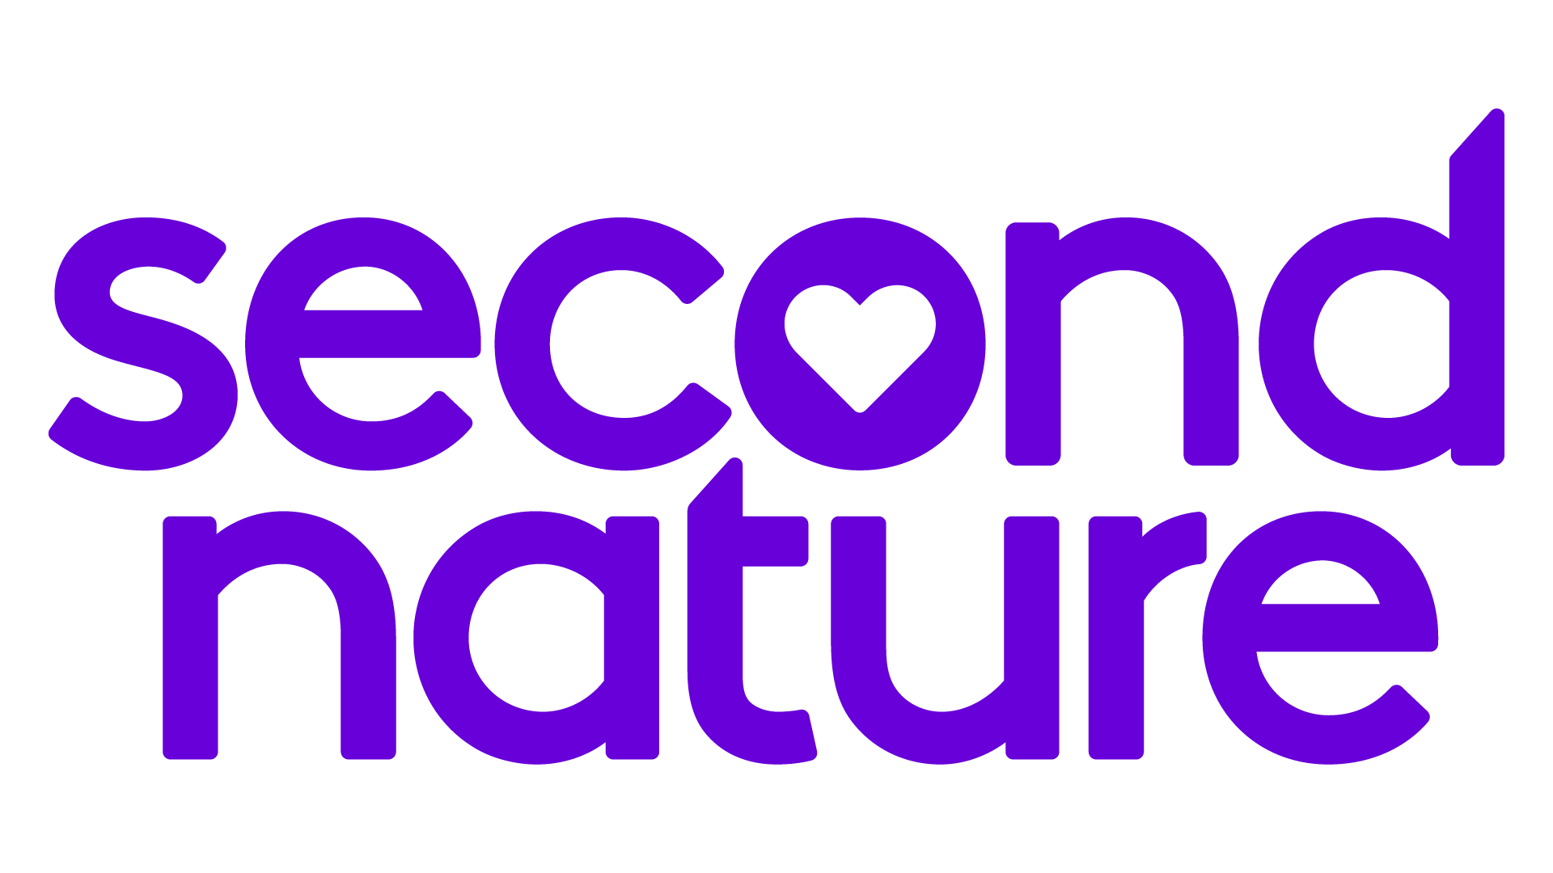
Welcome to your Key Property Management Resident Benefits Package!
To help you take advantage of your Resident Benefits Package, we’ve included some
helpful information below, including some “action items” to get things started!

What you need to know:

★ Move-in Concierge: Transferring the required utilities into your name is easy with our Utility Concierge Service. Simply schedule a convenient time with the Utility Concierge directly, by clicking here. You will need to know which utilities you are responsible for transferring into your name, as provided by Key Property Management The Utility Concierge service will take it from there! (This service is recommended if your move-in date is 72 hours or later from receiving this notice)

★ Resident Rewards: You’ll be rewarded for paying your rent on time with our Resident Rewards program. In the weeks ahead, watch for your welcome email from Piñata with a custom link to download the app to your smart device. Earn e-gift cards for simply completing your profile!

★ Credit Building: With each on-time rent payment you can track your Credit Building through the same Piñata App as described with your Resident Rewards (no action required here, just use the same app as your rewards app!)

★ ID Protection: We will set up your $1M Identity Protection account for you. Simply watch for your email confirmation with your account details.

★ Renters Insurance: You’re covered! By enrolling in our Resident Benefits Package, you meet the insurance requirements of the lease agreement. You’ll receive your Evidence of Insurance via email in the coming weeks. *Should you choose to obtain your own policy, you will be required to upload it to our carrier for verification – please see your lease addendum for all the details.

★ Filter Delivery: Changing the HVAC air filter is a tenant's responsibility per our lease agreement. If your home has HVAC, your air filter(s) will begin arriving on your doorstep shortly after you move in. All you need to do is change it upon arrival and continue to do so each time a new one arrives approximately every 90 days. Should you have any filter installation or delivery questions please contact Second Nature at hello@secondnature.com 1-800-308-1186, Mon - Fri 10 to 6 EST.

★ Online Portal Info: Pay your rent online, access documents and submit those maintenance requests any time, 24/7 at https://www.keypm.com/tenants. We know life is busy, we provide this tenant portal to help make these tasks easy to accomplish!

